**Computer Architecture Lab – CS322**

|  |  |  |
| --- | --- | --- |
| **Name:** M. Maheeth Reddy | **Roll No.**: 1801CS31 | **Date**: 10 October 2020 |

**Lab** **5 – Assembly Language Programming**

**--------------------------------------------------------------------------------------------------------**

**Age Predictor**

I have designed a simple text input/output game that predicts the age of the user through some simple Yes/No questions and is based on the Binary Search algorithm. This game is intended to be a stressbuster only.

**Design Overview**:

The game assumes that the age of a user is from 1 to 100 years. Based on the responses given by the user, it changes its estimate of the user’s age, i.e., the bounds 1 and 100 will be modified accordingly.

Two registers AL and AH are used to store the minimum and maximum possible values of the user. They are initialized to 1 and 100. The average of these values is 50. Therefore, the user is asked whether his/her age is 50 or lesser or greater. Consider a user who is 23 years old and is playing this game. Since his/her age is less than 50, he chooses option 1. Therefore, the value of AH register is updated to 50 and the game will try to search for his age in the range 1-50.

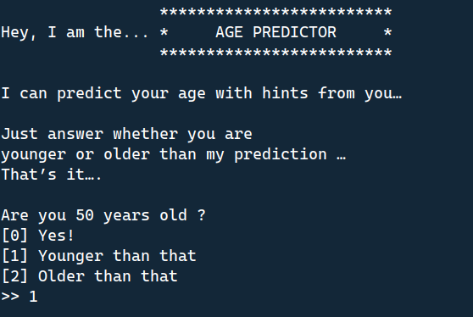

Now, the average of the minimum and maximum estimates is 25. So, the user is asked if his age is 25 or lesser or greater. Since he is only 23, he chooses option 1 again. So, the value of AH is updated to 25 and the game will try to search for his age in the range 1-25.

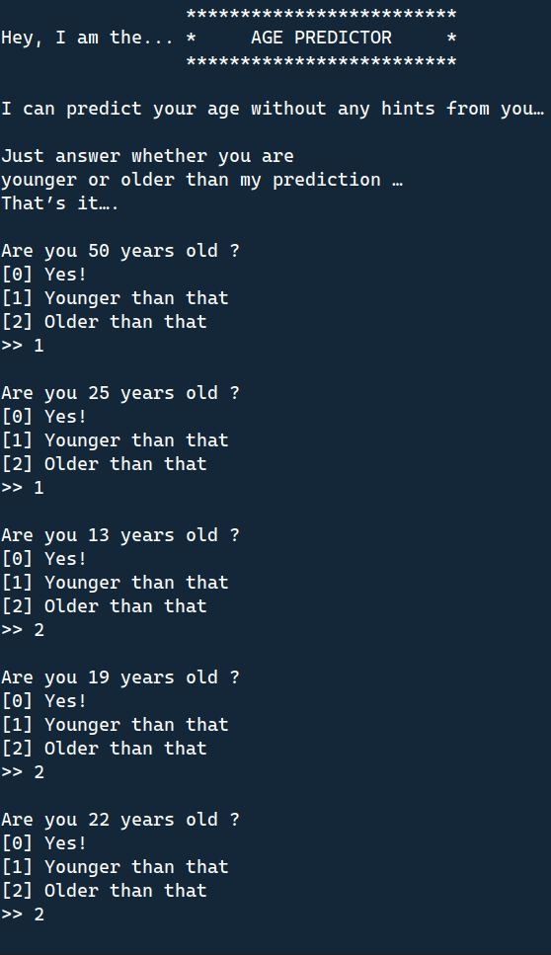

This time, the average of the minimum and maximum estimates is 13. So, the user is asked if his age is 13 or lesser or greater. Since he is 23 years old, he chooses option 2. So, the value of AL is updated to 13 and the game will try to search for his age in the range 13-25.



The average of the minimum and maximum estimates becomes 19. So, the user is asked if his age is 19 or lesser or greater. Since he is 23, he chooses option 2 again. So, the value of AL is updated to 19 and the game will try to search for his age in the range 19-25.



Now, the average of the minimum and maximum estimates is 22. So, the user is asked if his age is 22 or lesser or greater. Since he is 23, he chooses option 2 again. So, the value of AL is updated to 22 and the game will try to search for his age in the range 22-25.



Now, the average of the minimum and maximum estimates is 23. Since this is the user’s age, he chooses option 0, and the game ends.

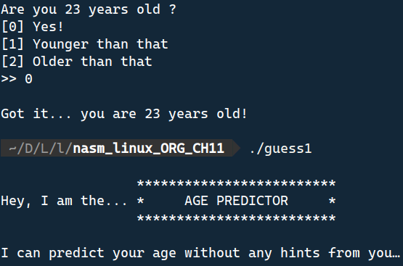

**Controls**:

For the queries about the age, enter:

**0** – If your age matches the one in question

**1** – If it is lesser

**2** – If it is greater

If any other keys are pressed, they are ignored, and user is prompted again for the choice.

In this manner, I have implemented a modified version of the Binary Search algorithm, driven by inputs given by the user. This game can also be used for number guessing. The user can think of a number in their mind, and the game tries to predict that number in a way similar to the game I have described.